Instructions for Students Using Question Mark for eTesting

To Start the Quiz:
- Double-click the “Questionmark Perception” icon on the desktop.

- A dialog box will appear asking for name and password.

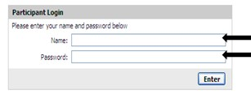
- Type in your JIC ID number as both “name” and “password.”

- The next page will show the list of available exams.
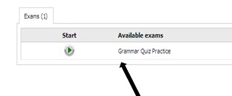
- Make sure that the language selected in the top right corner of this page is “English”:

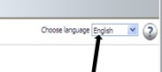

- Double-click your exam in the list of “available exams.”
During the Quiz:
- After you have answered a question, click on “Next Question >” to move on. Do NOT click on the “Submit” button if there is a “Next Question” button available.

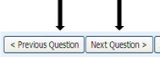

- To go back and change an answer, click on “< Previous Question.”

- Keep an eye on the small bar in the upper right corner of the screen. It will turn red to show how much of the test is answered. Next to it, you can check the time you have left.

- If you see no “Next Question” button, you have finished this section of the quiz. NOW click “Submit” to finalize your answers.

IMPORTANT: once you click “Submit,” you will not be able to go back and change your answers. Click “Submit” only when you are sure you are ready.

To Finish the Quiz:
- Once you have completed the quiz, you will see a “Home” button at the lower right. Click here to leave the quiz.

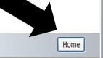

- Now click on “logout” in the upper left corner.

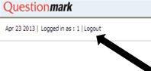
- Done!

