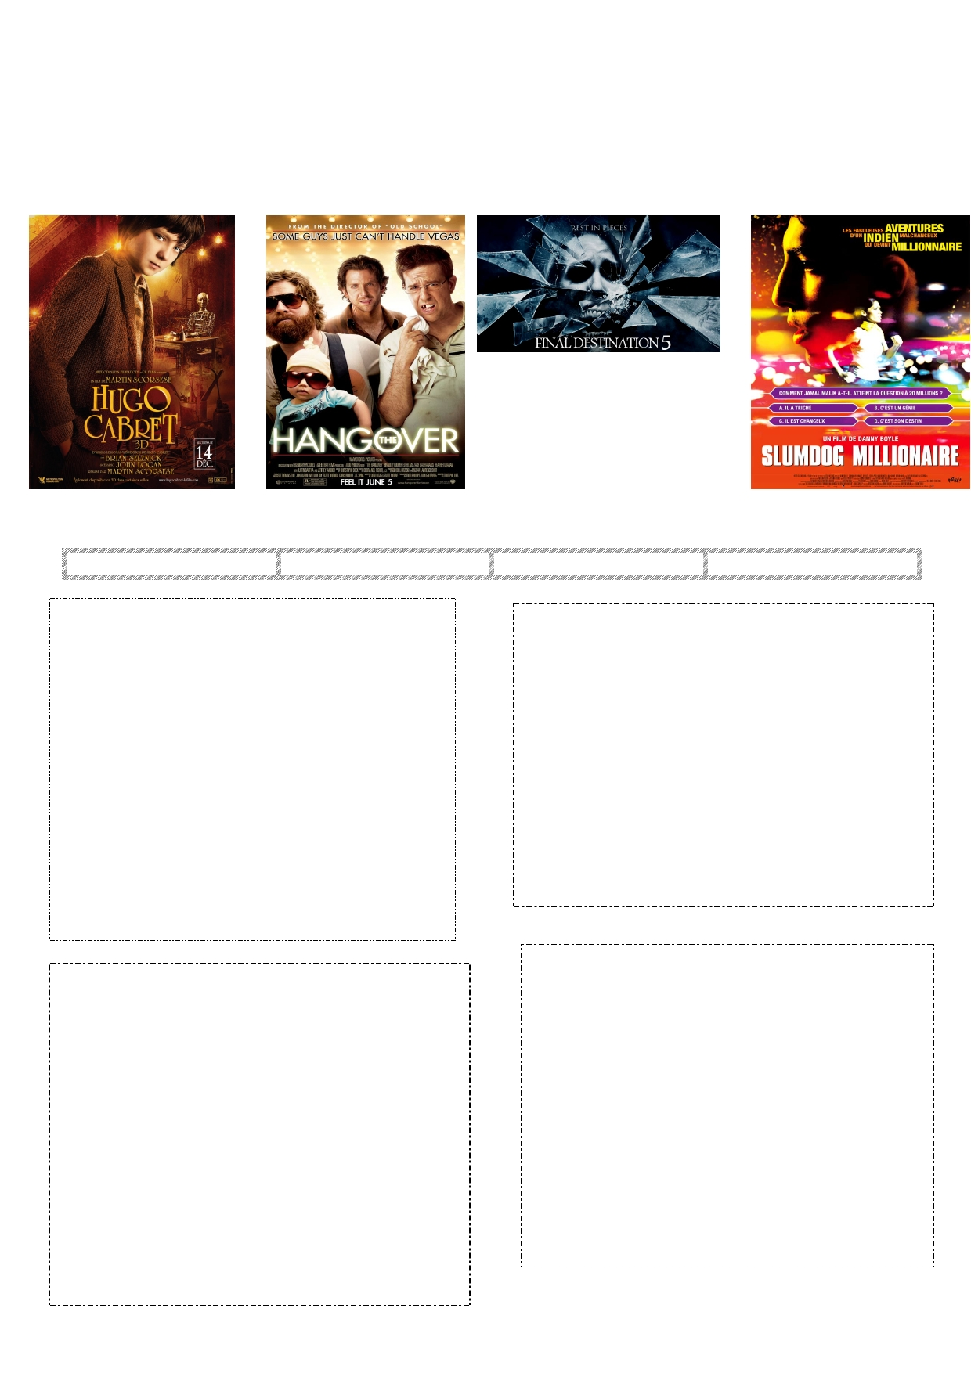SFL/METU October 2012
Dept. of B.E.
LL Pre-Int. Unit 3
WHO 3 ELEMENTARY GROUP
KE Y
TASK 1. Read the movie reviews quickly and match them with the photos and write the names of the
movies in the blanks in the reviews.

TASK 2. Match the following movie genres with the movie reviews and write the genre of each movie in the blanks.
horror comedy mystery & suspense drama & romance

Name of the Movie: ____ ___________
Genre: ____________________

1

Name of the Movie: ___________________
Genre: _______

2

Hugo is an orphan boy who lives in a train station. His
father dies in a fire and Hugo is sent to live with his drunken uncle. When the uncle disappears one day, Hugo decides to maintain the clocks on his own. His
talent for engineering leads him to steal tools and other
items from a toy-shop owner in the station. Hugo needs these pieces to rebuild a mechanical man which he was restoring with his father. Hugo's run-in with the old man leads to a friendship with his goddaughter, Isabelle (Chloe Grace Moretz), who unknowingly has
the last item that Hugo needs to make the mechanical
man work again.
The movie won 5 Oscars but the story is unfortunately
tedious. It is slow and confusing for children. It lacks
wonder for children. It's not worth seeing at all!
The movie begins with a vision, as Nick joins his friends
at an auto race and has a feeling of a horrible disaster that
kills his friends and others. When he comes out of this nightmare, Nick panics and persuades his friends to leave, escaping seconds before Nick's frightening vision becomes a terrible reality. The people think that they've cheated death, but unfortunately for Nick and his
girlfriend, Lori, it is only the beginning. His dreams
continue and the crash survivors begin to die one-by-one- -in increasingly shocking ways.
This fifth series of the movie is unfortunately boring. The
cast is not very good and convincing and the plot is dull because it is the repetition of the previous series.

Name of the Movie: _______________________ 4
Name of the Movie: _________________________ 3 Genre: __________

Genre: ___________________
An eighteen-year-old orphan who is from the slums of
Mumbai is accused of cheating and he tries to prove his innocence. He is also trying to compete to win 20 million rupees on India's "Who Wants to Be a Millionaire". He's one question away from taking the top prize on the game show, but it isn't going to be easy because Jamal is
arrested by police. Jamal begins reflecting back on his
childhood. He recalls his though childhood and his love Latika. Jamal's experiences brought him the knowledge which he needed to answer the difficult questions on Who Wants to Be a Millionaire.
It's an exciting story of Jamal. 60 million viewers are
eager to see if he'll correctly answer the final question.
The story keeps you on the edge of your seat. The music
is amazing and the effects are spectacular. Don't miss it!
A Las Vegas bachelor party turns into a race against time
when three friends of a groom awaken. Three friends go to a bachelor party and when they come back to their hotel room, they find a six-month-old baby in the closet and a tiger in the bathroom. Also, they realize that their friend (the groom) is missing. In 48 hours, Doug (the
groom) must be in the church for the wedding. With no
memory of the previous night's events and very little time to spare, the men try to find Doug to get him to the wedding back in Los Angeles.
The movie is fascinating because it has an adventurous
and funny story. The cast are gorgeous. In some parts the story is thought-provoking. I recommend this
entertaining comedy to everyone.

1

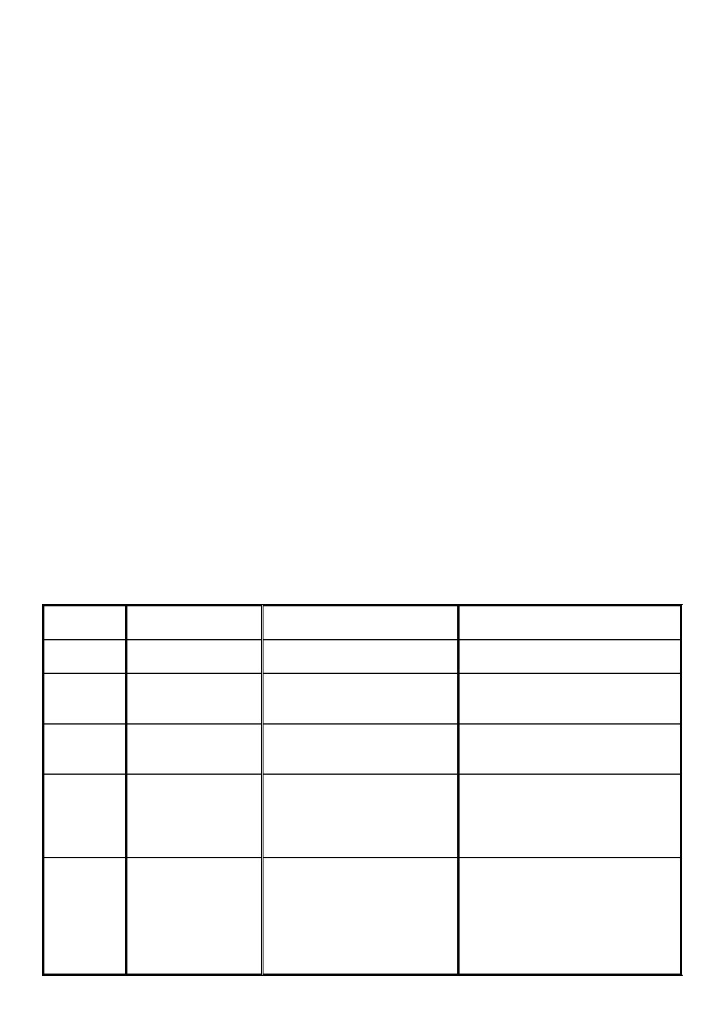TASK 3. Ask and answer the following questions with your partner.
1. What kind of films do you generally prefer to watch? Why?
2. What attracts you most to see certain films?
a. actors
b. director
c. story
d. reviews from critics
3. What is your favorite film? 4. Who is your favorite actor?
5. Have you watched any of the films in Task 1? Did you like them? Why?
TASK 4. Read the movie reviews and mark the sentences as TRUE (T) or FALSE (F).
T F 1. Hugo's uncle died in a fire.
T F 2. Hugo is good at engineering.
T F 3. Nick warns his friends about a terrible accident but his friends don't leave the auto race.
T F 4. Nick and his friends all die at the end of the film.
T F 5. Jamal is very successful in the game and everybody is surprised about this.
T F 6. The men find a six-month-old baby in the church.
TASK 5. Go over the reviews and find which one mentions:
1. a character who likes drinking alcohol? _______
2. a character who had a very difficult childhood? _______
3 a character who saves his friends from a dangerous situation? _______
4. a character who cannot be found before an important event? _______
TASK 6. Read the 2nd paragraphs of movie reviews again and study the adjectives in bold. Decide
which of the movies are recommended and which are NOT recommended and put the adjectives in the
correct column. Add one or two more adjectives of your own to the last column.

Movie 1

Movie 2

Movie 3

Movie 4

your own adjectives

Recommended /
Not Recommended

Positive Adjectives

Negative Adjectives

TASK 7. Match the following adjectives from the text with their definitions.

1.
2. 3.
4.
5. 6. 7.
8.
9.
10.
_____
_____ _____
_____
_____ _____ _____
_____
_____ _____
tedious
confusing convincing
dull
amazing
spectacular fascinating
gorgeous
thought-provoking
entertaining
a. very good
b. very interesting
c. beautiful; attractive
d. uninteresting especially because too slow or long; boring
e. making people think seriously about a subject
f. difficult to understand; puzzling
g. not interesting or exciting in any way; boring
h. enjoyable; amusing
i. impressive; fantastic; excellent
j. believable; realistic

TASK 8. Read the review of the movie "Tangled" and match the sections in the box with the relevant parts in the paragraph, and write the number of the paragraphs in the blanks provided.

Tangled

Comments

_____________

A beginning

_____________

A summary of the main
events

____ ________

1 "Tangled" is a computer-animated fantasy-comedy film which tells the
story of the long-haired Rapunzel. 2. When she was a baby, Rapunzel
was taken from her family and trapped in a tower in a far-away land by a
witch. She lives in the tower all alone, and every year on her birthday,
she watches the "floating lights" which are far away. One day, Flynn
Rider, who is a handsome thief comes, and Rapunzel "tangles" him with
her long hair. The thief wants to escape, so he makes an agreement with
Rapunzel. Together, they will go to see the "floating lights". On their
journey, Rapunzel discovers the world, and she finds true love and her
family. 3. This animation is fascinating because it has an adventurous
story. It has some nice music, and the effects are spectacular. Rapunzel
and Flynn are amazing. I recommend this entertaining comedy to
everyone - not only children but also their parents.

3

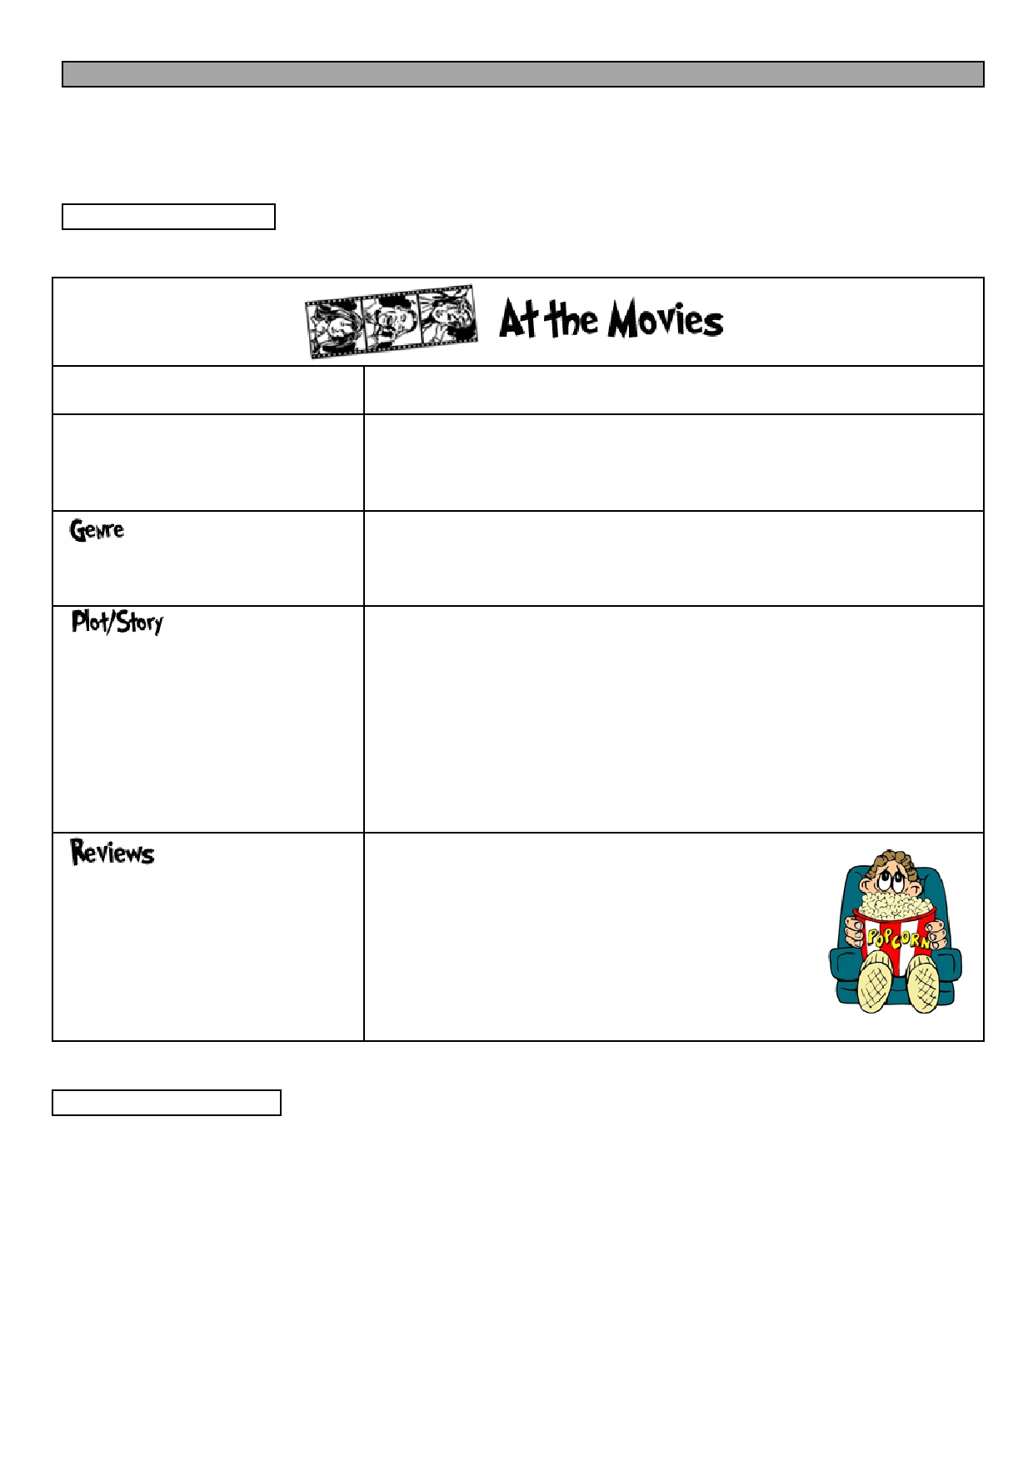WRITING TASK
You are asked to write a review of a movie for a student newspaper.
In about 8-12 sentences, write a movie review. While writing, you may use the vocabulary in this
handout and revisit the sections in your book 'Language Leader Pre-Intermediate Unit 3' for the
appropriate language structures and vocabulary.
I. PRE WRITING
First, you may want to plan your writing. Answer the questions in the table and take notes about the
movie and use these notes to write about it.

What is the name of the movie?

What kind of movie is it?

What's it about?
What happens in it?

Useful Language

________________________________

It's a ______________________

(e.g. science-fiction, horror, romantic comedy)

It's about _____ who _____.

(e.g. about people who fall in love, about people who take drugs.)

How is the music?
the story?
the acting?

How are the effects?
the cast?

II. FIRST DRAFT

………. is a …….. movie which tells the story of / which is about __________________________________
________________________________________________________________________________________ ________________________________________________________________________________________ ________________________________________________________________________________________
________________________________________________________________________________________
________________________________________________________________________________________ ________________________________________________________________________________________ ________________________________________________________________________________________
4

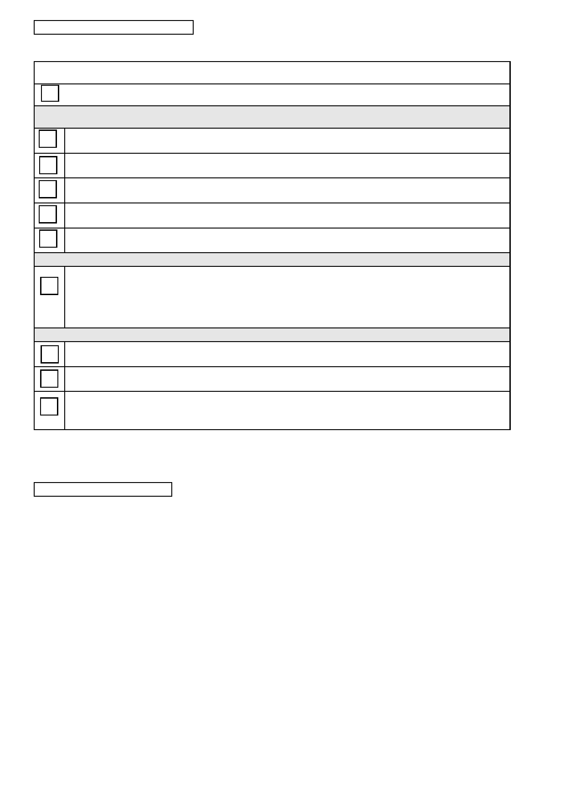III. SELF CHECKLIST
Before you write the second draft, use the checklist below to go over your work. Put a tick () in the
relevant box.
WRITING OUTPUT:
I wrote a movie review.
Mechanics:

All the words are spelled correctly.

All the sentences are punctuated correctly.

There are no capitalization mistakes.

All the sentences have a SUBJECT and a VERB.

There are no fragments or run-on sentences.
Grammar and Vocabulary:
I have used the 4 adjectives from the handout and LL-PIN Unit 3 and the adjectives I used are:
___________________ ___________________
___________________ ___________________

Organization:
I have made use of the pre-writing activities.

The paragraph is within the sentence limit.
I used the following linkers correctly:
___________________ ___________________ ___________________

IV. SECOND DRAFT
Correct your work according to the checklist. Then, re-write and hand it in to your instructor. Your
instructor will provide feedback on the content of your work.

5

V. NOTES FOR SELF-REFLECTION ASSIGNMENT
Look at the checklist and take notes in the table so that you can recognize your strengths and
weaknesses to improve your writing and help you reflect on your performance.

YOUR WORK & EFFORT

Did you allocate sufficient time
and energy for the tasks?

Did you make use of the self-
checklist?

If yes, how?

_________________________

_________________________

_________________________

If no, why?

_________________________

_________________________

_________________________

THE HANDOUT &
ITS CONTENT
ONE thing that you believe you learned and put into practice
well:
_________________________
_________________________

ONE thing that you need to work
on and improve:

_________________________

_________________________

_________________________

OVERALL EVALUATION

Are you satisfied with your writing
outcome?

Did you notice any improvements
in your writing?

If yes, what?

_________________________

_________________________

_________________________

If no, why?

_________________________

_________________________

_________________________

VI. FINAL DRAFT
Write your final draft and put it in your portfolio.

References:
• DBE Materials Achieve, METU
• www.eslprintables.com

6

