Use the following adjectives to describe the pictures below:
Elegant functional futuristic handmade innovative mass-produced retro simple streamlined stylish traditional up-to-date

The man is wearing really ………………… clothes. They are so fashionable and on cutting-edge of design.
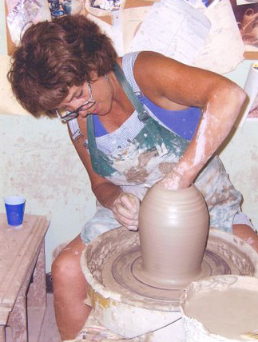
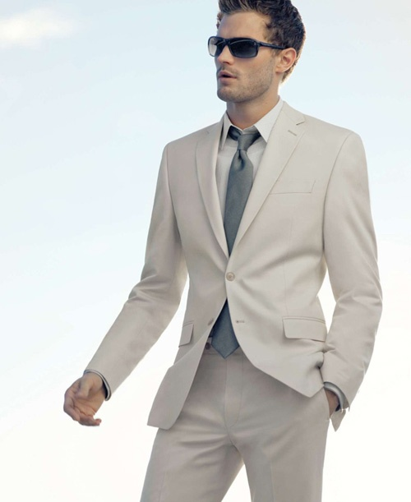

- Johnny is putting on an attractive suit. It is so ……………….. .
- Sameerah is very skilled in pottery making. The jug she's molding now is going to be her 450th …………………. Jug!

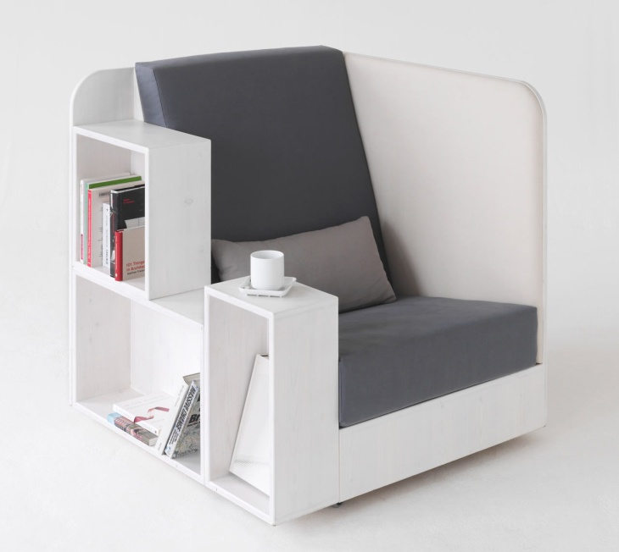
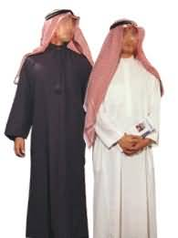
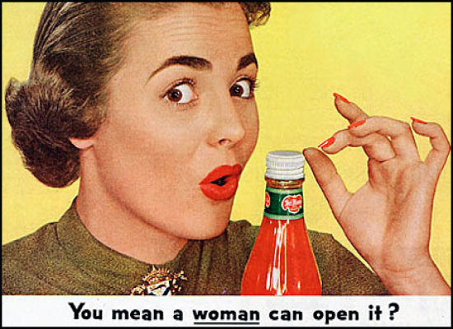

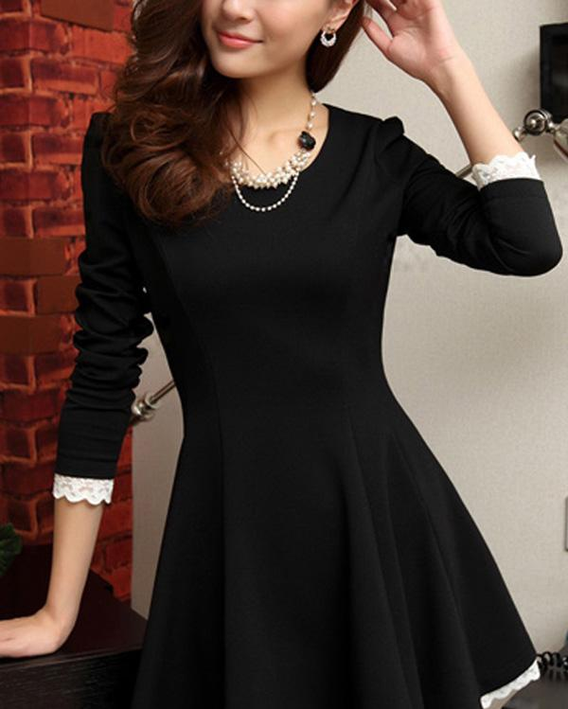

- The ketchup advert is very old-fashioned. Designers do not use hand-drawings any more to advertise products. This advertisement is really …………… .
- The ………………………. clothes of Saudi Arabia is the thobe, the ghutra, the ogal and the tagyyah.
- This sofa is very useful. There is a place for everything; the books, the coffee pad and the arm area to rest your hands. It is very …………………. .
- The girl is wearing a nice dress. There is not much of details on it. It is very ……………. .

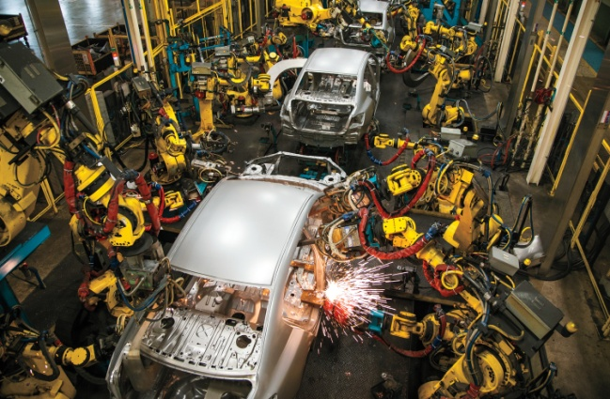
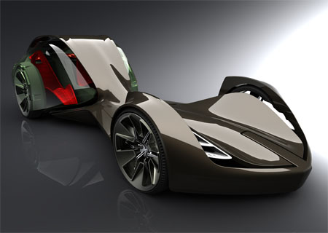
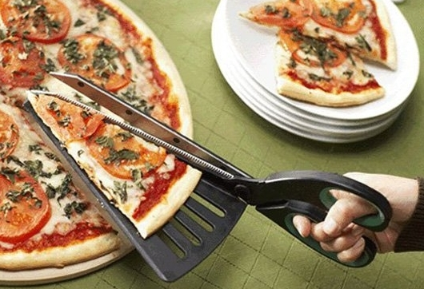
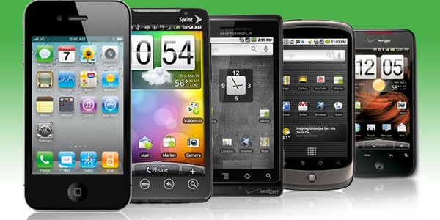
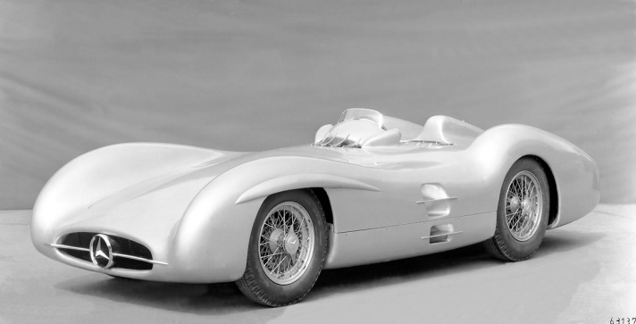

- The mobile phone market is full of ………………. Phones. They are modern and most of them are touch-screen.
- The pizza slicer is really ……………. . Who is the genius who thought of this?
- Cars nowadays are ……………….. . Factories employ manpower and machines to get the car productions completed.
- Car design of the future is not very much different from cars today. However, ………………… cars will have stronger and powerful horse engines.
- The car in the picture seems very effective. It does not have a lot of details we see in cars. The shape is …………………. .

