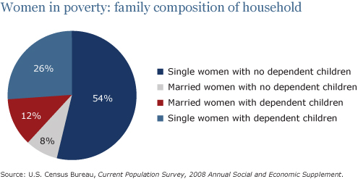

The pie chart shows the percentage of women in poverty. It is from the United States in 2008.
Summarize the information by selecting and reporting the main features and make comparisons where relevant.
The chart shows the percentage of women in poverty in the United States in 2008. The number of percentage................................................................................ ...................................................................................................................... ...................................................................................................................... ...................................................................................................................... ...................................................................................................................... ...................................................................................................................... ...................................................................................................................... ...................................................................................................................... ...................................................................................................................... .............................................................................................................................................................................................................................................................................................................................................................................................................................................................................................................................................................................................................................................................................................................................................................................................

