JIC ENGLISH 001
WRITING PRACTICE NAME:
Write a short paragraph about TOKYO.
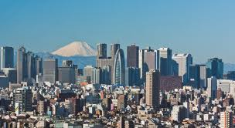
capital of Japan
middle of the country
modern, busy
13 million (population)
a lot of universities, beautiful bridges, amazing restaurants
summer- hot / winter: wet, cold
famous: sushi restaurants, art galleries, museums
_____________________________________
__________________________________________________________________________________________________
__________________________________________________________________________________________________
__________________________________________________________________________________________________
__________________________________________________________________________________________________
__________________________________________________________________________________________________
__________________________________________________________________________________________________
__________________________________________________________________________________________________
__________________________________________________________________________________________________
__________________________________________________________________________________________________
__________________________________________________________________________________________________
__________________________________________________________________________________________________

