ENGLISH 002 GRAMMAR WORKSHEET – Q(4)
Q(4) Define each person’s job using “who”.
1) A pilot______________________________________________________________.
2) A mechanic__________________________________________________________.
3) A teacher____________________________________________________________.
4) A florist_____________________________________________________________.
5) A barber_____________________________________________________________.
6) A waiter____________________________________________________________.
7) A photographer______________________________________________________.
Q (5) Define the places in the pictures using “where”.
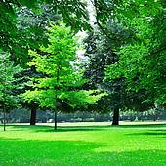
1) A pharmacy_________________________________________________________.
2) A stadium__________________________________________________________.
3) A grocery store______________________________________________________.
4) A café______________________________________________________________.
5) A gym______________________________________________________________.
6) A park______________________________________________________________.
7) A library_____________________________________________________________.
Q(6) Define the nouns below using “which / that”.

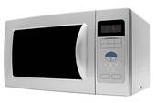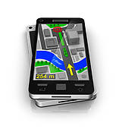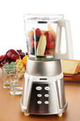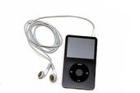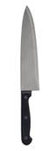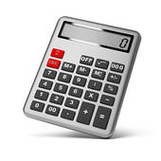

1) A microwave oven___________________________________________________.
2) A GPS navigator______________________________________________________.
3) A juice blender______________________________________________________.
4) A compass__________________________________________________________.
5) An MP3 player_______________________________________________________.
6) A knife______________________________________________________________.
7) A calculator__________________________________________________________.

GOOD LUCK

