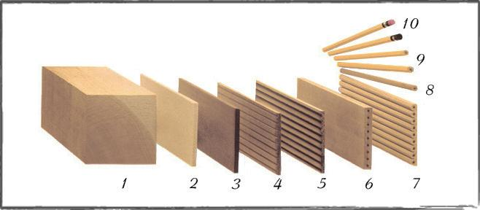
Have you ever wondered how a pencil is made? Well, you have all the information required below. First, you need to look at the picture above; then you need to use the information below to help you WRITE a paragraph about the process of making of pencils. The verbs in the PROCESS column (written in bold) should be used in PASSIVE forms. WRITE a paragraph between 90-120 words about the process of making pencils.
STEPS | MATERIALS | PROCESS
Step 1 | -pencil stock | -cut into “Pencil Blocks”
Step 2 | -pencil blocks  -pencil slats  -slats | -cut into “Pencil Slats” using specially designed circular saws.  -sort by width and grade for further processing.  -Some slats cut to smaller widths (called “narrow ply”) or shorter lengths (called “memos”) in order to eliminate the defects and to produce a variety of usable grades and plies of pencil slats.
Step 3 | -pencil slats  -the slats | -treat with wax and stain to obtain uniform color and improve the machining and sharpening characteristics of the wood for future processing.  -pass through a final inspection process and then are packaged and shipped to “Pencil Factories” all over the world.
Step 4 | -groover machines | -cut grooves into the slats to accept the writing core (or “lead”).
Step 5 | -writing cores (made from a mixture of graphite and clay) | -place into the grooves. Coloring pencils may use wax-based cores while many other formulations use in cosmetic pencils.
Step 6 | -second grooved slat  -sandwiches | -glue onto the first – making a “sandwich” – by a machine called a “lead layer.”  -sandwiches then clamp and hold together tightly while the glue dries.
Step 7 | -sandwiches  -sandwiches | -transfer to a “Shaper” and first trim to assure that the sandwich is square and that all the pencils will be the proper length.  -then the sandwiches machine into pencil shapes such as hexagonal, round or triangular.
Step 8 | -pencils from the sandwiches | -ready for further processing. Any pencils with defects discard at this point.
Step 9 | -each pencil  -some pencils  -most pencils | -paint in a machine receiving from 4-10 coats of lacquer, depending on the desired quality of the finish and the color depth. A recess cut to accept the ferrule.  -after painting, some pencils wrap in decorative film or foils with fancy designs.  -most pencils imprint with the brand name by stamping the foil into the surface of the pencil.)
Step 10 | -on a tipping machine | -an eraser and a ferrule (the metal ring that holds the eraser to the pencil) crimp into place on each pencil.

First of all the making of pencils is consisted of ten steps. ………………………………………………………………………
……………………………………………………………………………………………………………………………………………………………………………………………………………………………………………………………………………………………………………………………………………………………………………………………………………………………………………………………………………………………………………………………………………………………………………………………………………………………………………………………………………………………………………………………………………………………………………………………………………………………………………………………………………………………………………………………………………………………………………………………………………………………………………………………………………………………………………………………………………………………………………………………………………………………………………………………………………………………………………………………………………………………………………………………………………………………………………………………………………………………………………………………………………………………………………………………………………………………………………………………………………………………………………………………………………………………………………………………………………………………………………………………………………………………………………………………………………………………………………………………………………………………………………………………………………………………………………………………………………………………………………………………………………………………………………………………………………………………………………………………………………………………………………………………………………………………………………………………………………………………………………………………………………………………………………………………………………………………………………………………………………………………………………………………………………………………………………………………………………………………………………………………………………………………………………………………………………………………………………………………………………………………………………………………………………………………………………………………………………………………………………………………………………………………………………………………………………………………………………………………………………………………………………………………………………………………………………………………………………………………………………………………………………………………………………………………………………………………………………………………………………………………………………………………………………………………………………………………………………………………………………………………………………………………………………………………………………………………………………………………………………………………………………………………………………………………………………………………………………………………………………………………………………………………………………………………………………………………………………………………………………………………………………………………………………………………………………………………………………………………………………………………………………………………………………………………………………………………………………………………………………………………………………………………………………………………………………………………………………………………………………………………………………………………………………………………………………………………………………………………………………………………………………………………………………………………………………………………………………………………………………………………………………………………………………………………………………………………………………………………………………………………………………………………………………………………………………………………………………………………………………………………………………………………………………………………………………………………………………………………………………………………………………………………………………………………………………………………………………………………………………………………………………………………………………………………………………………………………………………………………………………………………………………………………………………………………………………………………………………………………………………………………………………………………………………………………………………………………………………………………………………………………………………………………………………………………………………………………………………………………………………………………………………………………………………………………………………………………………………………………………………………………………………………………………………………………………………………………………………………………………………………………………………………………………………………………………………………………………………………………………………………………………………………………………………………………………………………………………………………………………………………………………………………………………………………………………………………………………………………………………………………………………………………………………………………………………………………………………………………………………………………………………………………………………………………………………………………………………………………………………………………………………………………………………………………………………………………………………………………………………………………………………………………………………………………………………………………………………………………………………………………………………………………………………………………………………………………………………………………………………………………………………………………………………………………………………………………………………………………………………………………………………………………………………………………………………………………………………………………………………………………………………………………………………………………………………………………………………………………………………………………………………………………………………………………………………………………………………………………………………………………………………………………………………………………………………………………………………

