English 002 Practice Quiz

PART I: Describe what’s happening in each picture.

A B C D E
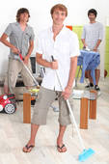
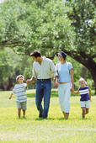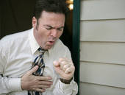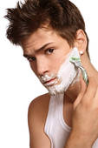

A) The men are cleaning the floor.

B)___________________________________________________________.

C)___________________________________________________________.

D)___________________________________________________________.

E)___________________________________________________________.

PART I: Describe what you did last week using the information in the table.

Wednesday | Thursday | Friday
_ a barbecue at the beach  _ a new shirt | _ my car to the garage  _ a movie on TV | _ spaghetti for lunch

1) I had a barbecue at the beach last Wednesday.

2)___________________________________________________________.
3)___________________________________________________________.

4)___________________________________________________________.

5)___________________________________________________________.

PART I: Describe your main daily activities using the pictures.

A B C D E
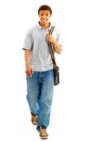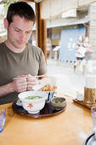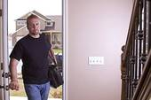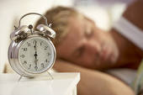

A) I wake up at 6:30 every morning.

B)___________________________________________________________.

C)___________________________________________________________.

D)___________________________________________________________.

E)___________________________________________________________.

PART I: Answer the following questions in your own words.

1) What were you doing when the game started?

_____________________________________________________________.
2) What did the thief do when he saw the police?

_____________________________________________________________.
3) What was Linda doing while she was driving to school?

_____________________________________________________________.

