How tortillas are made.
 | remove | Corn kernels (yellow bits) | from cob
 | dry | kernels | in sun
 | boil | kernels, lime | 1 or 2 hours
 | pour off | water
 | grind | cooked kernels | into dough
 | call | dough | “masa”
“tortillera” (person) | form | masa | into flat circles
 | cook | circles | on a flat metal plate
 | call | metal plate | “comal”
people | eat | tortillas | with beans, meat, etc.
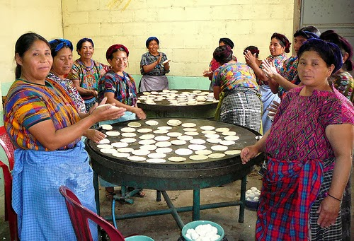
NB: lime, dough and masa are non-count nouns .
The picture shows some Guatemalan tortilleras cooking tortillas on a comal.
First, ______________________________________________
___________________________________________________
___________________________________________________
___________________________________________________
____________________________________________________________________________________
____________________________________________________________________________________
____________________________________________________________________________________
____________________________________________________________________________________
____________________________________________________________________________________
____________________________________________________________________________________
____________________________________________________________________________________
____________________________________________________________________________________
____________________________________________________________________________________
____________________________________________________________________________________
____________________________________________________________________________________
____________________________________________________________________________________
NOTE: because you are not going to try and make tortillas, these are not instructions (so don’t use imperative). Also, you do not have to make all the sentences passive, but most of them should be passive. Use Simple Present because this is how tortillas are made (past, present, and in the future.)

