English 002 Grammar Worksheet - ( Midterm )
Question (1) Use the information in the table and the box below to write correct sentences about the four drivers.
Driver | Car Model | Car Price | No. of Accidents | Monthly visits to London
Alex | 2005 | $25,000 | None (0) | Twice
John | 2008 | $28,000 | (2) | Three times
Peter | 2002 | $17,000 | (5) | Five times
Carlos | 2011 | $42,000 | (3) | Once

careful - new - few - careless - expensive
cheap - many - old - frequent - good
- Comparative Adjectives:
A) John’s car is newer than Peter’s.
B)________________________________________________________________.
C)________________________________________________________________.
D)________________________________________________________________.
- Superlative Adjectives:
A) Carlos has the newest car of all.
B)________________________________________________________________.
C)________________________________________________________________.
D)________________________________________________________________.
- Comparative Adverbs:
A) John drives more carefully than Carlos. B)________________________________________________________________.
C)________________________________________________________________.
D)________________________________________________________________.
- Superlative Adverbs:
A) Alex drives the most carefully of all.
B)_______________________________________________________________.
C)_______________________________________________________________.
D)_______________________________________________________________.
Question(2) Use the adjectives / adverbs to write double-comparative sentences.
hard high A) The harder you study, the higher scores you get.
healthy strong B)_________________________________________.
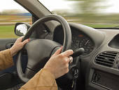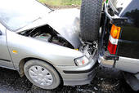
slow few C)__________________________________________.

Question (3) Use the pictures to write repetitive comparatives.
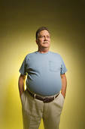 A) He’s getting fatter and fatter.
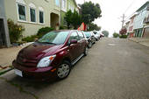 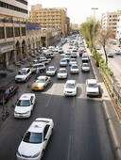 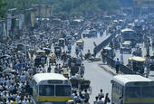 B) _________________________________________.
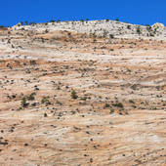 C) __________________________________________.

Question (4) Make Wh-Questions to the underlined phrases.
Carol is a housewife. She is married to Francis. They have three children and they love them so much. Last night, Carol was eating dinner with the kids in the kitchen when Francis came back home. He was carrying a heavy bag which had some toys for his children. They felt very happy when they saw the new toys. They started playing when they finished eating dinner.
1) Who is Carol married to? Francis
2) ___________________________________________________? Three.
3) ___________________________________________________? In the kitchen.
4) ___________________________________________________? A heavy bag.
5) ___________________________________________________? Very happy.
6) _____________________________________________? They started playing.
Question (5) Give the best advice using should / shouldn’t.
1) Claudia has a severe toothache.
A) She should see a dentist.
B) She shouldn’t eat sweets.
2) Majid is going to travel to Malaysia next week.
A) ______________________________________________________________.
B) ______________________________________________________________.
3) Jack overuses his I-phone at school.
A) ______________________________________________________________.
B) ______________________________________________________________.
4) It’s raining heavily and the roads are slippery.
A) ______________________________________________________________.
B) ______________________________________________________________.
Q(6) Fill in the gaps using ( since / for ).
1) My friend has been a pilot_____________ he was 25.
2) We have been in Jubail _____________ last night.
3) Tom has had his silver watch ___________ a long time.
4) I have been here ________________an hour.
5) My father has worked in Aramco ____________ten years.
6) Linda has known Fatima _______________ she was a child.
7) I haven’t seen Tom __________ages.
8) Faisal hasn’t eaten anything ___________he came back home.

Q(7) Use the information in the table to form sentences in the Present Perfect with already / yet.
clean the house | No
make lunch | Yes
feed the baby | No
buy groceries | Yes
see a movie | No

1) Claudia hasn’t cleaned the house yet.
2) ________________________________________________________________.
3) ________________________________________________________________.
4) ________________________________________________________________.
5) ________________________________________________________________.

Q(8) Rewrite the sentences using Affirmative and Negative Present Perfect OR Present perfect Progressive Forms.
1) Chris joined SABIC in 1985. He is still working there.
- Chris has been working at SABIC since 1985.
- Chris hasn’t quit his job yet.
2) Peter graduated from college three months ago. He is still looking for a job.
__________________________________________________________________.
__________________________________________________________________.
3) Claudia bought her house a few years ago. She is planning to sell it soon.
__________________________________________________________________.
__________________________________________________________________.

4) The police started looking for the thief last week. They can’t find him.
__________________________________________________________________.
__________________________________________________________________.
5) Ahmed’s holiday started last week. He is enjoying his time with his family.
__________________________________________________________________.
__________________________________________________________________.

Q(9) Fill in the gaps using the correct form of can / could.
1) I ___________swim when I was a child, but now I ___________swim very well.
2) Ali is very interested in languages. He _____________speak three languages.
3) Peter is too young. He _______________ drive a truck.
4) John is a famous chef. He ________________ cook all kinds of food.
5) My father _________run long distances when he was young, but now he can’t.

GOOD LUCK

