JIC ELC
ENGLISH 001 WRITING PRACTICE
Study the information about Argentinian soccer star Lionel Messi and write a short biography of the player.

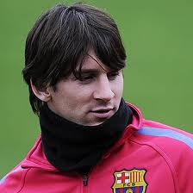

June 24, 1987 - Rosario , Argentina
1998 - Spain (a serious health problem)
2003 – first match in FC Barcelona
October 2004 – first official match with Espanyol-
Olympic Stadium- (0-1)
June 2005 - the “Golden Ball’ award – the best player
Sept 2005 – Spanish passport
A 10-year contract with FC Barcelona
Now - still in FC Barcelona- the most expensive player

LIONEL MESSI
_____________________________________________
_____________________________________________
_____________________________________________
_____________________________________________
_____________________________________________
_____________________________________________
_____________________________________________
_____________________________________________
_____________________________________________
_____________________________________________
_____________________________________________
_____________________________________________
_____________________________________________
_____________________________________________
_____________________________________________

