Interiors
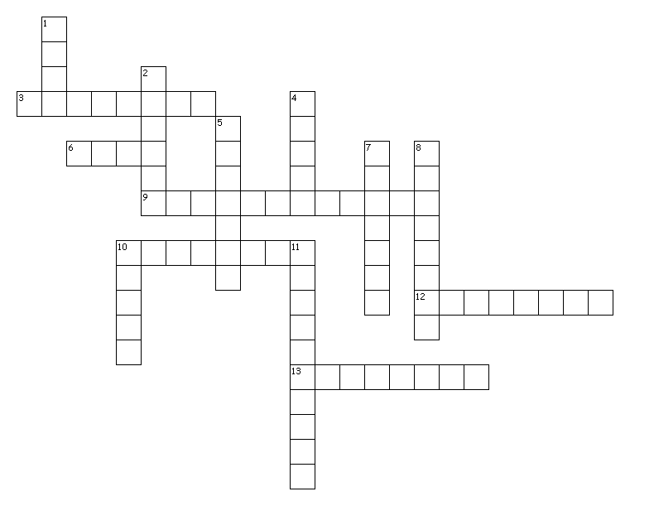
Across
3. place for showering
6. for writing on
9. for storing food
10. for storing dishes
12. for storing books
13. for sitting down and resting your arms
Down
1. a comfortable place for two or more to sit
2. for cooking on
4. for eating on
5. place for sleeping
7. place for cooking
8. for storing clothes
10. for sitting on
11. for washing dishes

