How to leave JIC (2015 Edition)

Stage 1. (JIC Clearance)
Get the form F04.21 entitled Clearance Certificate (1 page) from your dept secretary (Abdul-Malik for ELC) and fill out the details at the top (Name, ID, Dept, Tel ext.plus mobile, and last day of work. I left that blank until confirming, but it's the last working day for the semester, not the day your contract expires.
Go to the library, and if you have no books out and no fines to pay they will sign JIC Library Books (No. 1) for you.
Now go to the Bookstore (Syed Munawar) and ask for a printout of the books they want you to hand in. Get the list first, as it seems to be somewhat random as to which books you should return. Once you have collected a copy of each book from the back of your office, trashcan, or other teachers, take them across and get the MEDIA signature (No. 2)
Now go directly to the Media Print-shop (next to the Bookstore) and as I am sure you have nothing borrowed from there they will sign the spot (No.3).
If you have a car, peel off the parking sticker (green triangle) and the parking chip (small white rectangle thing) and go to office 34 in the Admin Building and Mr, Farid will give you a temporary parking permit and sign JIC Security (No. 4). If you don't have a car just see him and he will sign for you. NOTE: If you sell your car first, don’t forget to peel off and save both these stickers, or it’s a big mushqilla.
Now, go upstairs (same building) to the IT department and find someone there who will check what (if any) IT things are in your name. If none, they will sign box No. 5. If something (e.g. a printer) is in your name, come back to your department and ask your dept secretary to transfer ownership to your office mate.
Now, the next signature is from Abdulaziz Asiri in Admin, Office number 77.
Now you have completed the first box of signatures. Come back to your department and get your Course Director to check a few boxes and sign, then go to the Chairman and he will sign. DO NOT GET ANY ACTING persons to sign, it must be the real Director in person.
Last signature for this sheet is from Dr. Eid Al-Hajri, the ETA Deputy. If he isn't there, you'll have to leave the form with his secretary as again he himself needs to sign it.

Congratulations, you have filled in the first form, and to complete stage one take the form back to Abdulaziz in Admin office 77 and you will get an RC Clearance Form which is two pink and white pages in duplicate in a white folder.

Stage 2 (RC Clearance form)
Extremely Helpful Map in case my instructions are not clear for you.
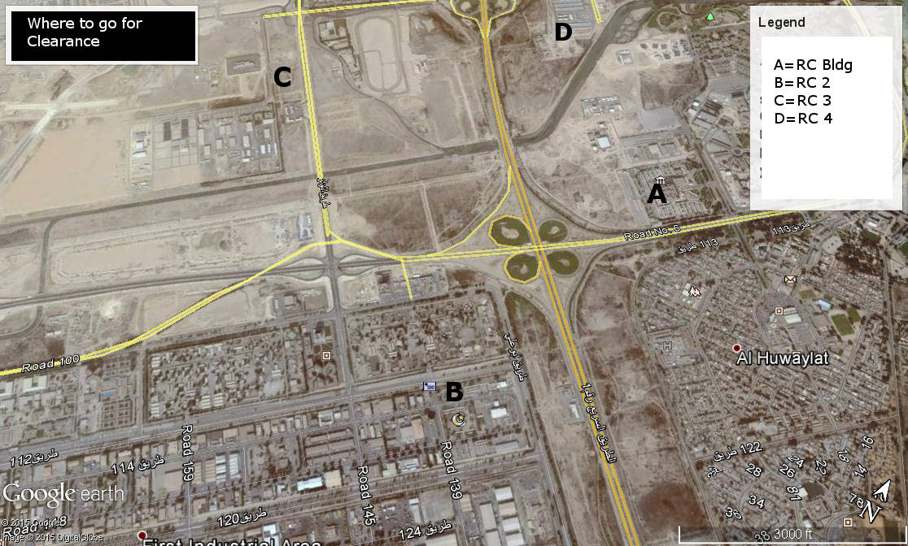

Get someone to fill in the details section at the top in Arabic. It probably works if you fill it out in English, but I'm not sure.
1) Employee Direct Supervisor: Your Head of Department will do this for you, as stated above DO NOT GET ANYONE ELSE to sign this on behalf of him, or you will be sent back to start again.
2) Social Services Dept. Go to the RC Building in front of the Marafiq Offices and the NCB in the Support Industries area (B on map). On the 3rd Floor you can get this signed.
3) Later
4) Purchasing and Warehouse. Same place as 2), different office.
5&6). Later
7) Property. Same Building as 2&3, but first go to the second floor and get two or three signatures there, then return to the 3rd Floor and get the final signature. If you have RC accommodation off-campus you need something from the housing dept at the college, I think it’s a guarantor form where someone who trusts you promises to pay any bills or destruction you leave behind. If nobody trusts you then bully or bribe someone to sign this.

5) General Utilities. Go to this building, it's more or less opposite the Equestrian center, (C on map). From location B, go over the highway, past the gas station to the lights (Masjid Rd), turn left, then left again and it’s on the left. You need someone there to check you out in the computer then someone else will sign off your form.

9) (on the second page) Transport & Equipment. This building is fairly close (but not close enough to walk), it’s the place on Masjid Rd with 100s of white school buses parked in front. (D on map). Unless you have an RC car, they will sign this off for you.

3) Now, to the main RC Building (A on map). Enter through the staff entrance on the below ground level and walk down the corridor behind the security desk, turn right and you can get the Administrative Services signature.
6) Head back, but where you turned right, keep going straight and you'll get to the IT department. Assuming you have no RC computers issued to you (this is different from JIC issue, so you probably don’t) they will sign you off.
10) Now return to the security desk and take the elevator up to the 5th floor. Don't look for the Financial Accounting Department, you want the Accounting Department. This is a quick and easy signature, PROVIDING YOU ALREADY have No. 7 (Property Dept) correctly signed.

That leaves you with sections 8 (Industrial Security), 1 (Employee Services/Employee Relations), 12 (Employee Services Payroll) and 13 (You) to fill out.

When you are ready to relinquish your ID card, preferably about two weeks before you leave, go to the Passports Office in the little building behind the main RC Building. Your name should be on a list pinned to their wall. If not, you can’t leave. You should also have sold your car and not have any vehicles in your name, or can’t leave either. They will take your ID card and iqama. This is a big problem, and probably illegal, but what can we do? You need your iqama to hand in to Immigration when you leave the country, I was told they will give the iqama back to me with my passport, I assume once they have issued the final exit visa and letter. You then go to another office in the same little building and get that section signed off.

I haven't done these yet, but what I know up to now is that you do sections 12 & 13 somewhere inside the RC building, and 13 you sign yourself after getting all the others done. You then hand the form in to someone (I don't know who just yet) who sits near Abdulrahman Al-Qassab who does the school fees certificates, then wait a few days for the biggest check you can imagine (depending on your length of service). You can also see Ahmed Al-Malki (I believe) in the same general area to give you a ticket home voucher, if you don’t have that yet. As I haven’t done these final steps yet I cannot answer questions about how huge your bundle of cash is, how long it takes to pay, and if they need any other documents, but everywhere I went people were friendly and pointed me in the right direction(s) to find the signatories.

I hope that this has been of some use, and someone who is leaving next year updates it with any changes that may happen.
Every success to all the continuing staff in all departments,
Michael Byrne
ELC

