ENGLISH 002 SKILLS WORKSHEET - (4)
Q(1) Complete the sentences using the words in the box. There are four extra words.
- old-fashioned – research – steady – threat – influential – devastation - safety
- modification – trend – imitate – collision – structures – smash – deadline –
- design – breakthrough – expectancy – prototype – model – solve - dubbed

1) The earthquake has caused huge__________________to the country.
2) Wearing baggy pants and black sunglasses is a new________________nowadays.
3) The MBC Channel displays Turkish series that are________________into Arabic.
4) The scientists are trying to prevent the_____________of meteorites with the Earth.
5) There is a___________________increase in the number of smokers in Saudi Arabia.
6) Listening to the radio has become an________________habit nowadays.
7) Khalifa Tower in Dubai is one of the most fantastic_________________in the Gulf.
8) Air pollution poses a real___________________to the environment.
9) Mr. Smith is a very famous architect. He can_________________huge buildings.
10) The scientists used hi-tech rockets to__________________into the asteroid.
11) Medical advances have made life________________rise dramatically.
12) The new design needs some______________________to be more attractive.
13) Christian Dior was one of the most________________fashion designers.
14) The Chinese companies try to________________the products made in the USA.
15) Scientists made a_______________________in the fight against cancer last year.
16) You have to meet the_________________of submitting the report to the manager.
17) We should do a_______________test on the new machines before we use them.
Q(2) Fill in the gaps using the phrasal verbs in the box. There is one extra verb.
die out - pick up on – keep up with – find out – slow down – take over

1) Lucy goes shopping twice a month because she likes to_____________new fashions.
2) The mechanic can’t__________________what makes the car overheat.
3) Julia is very smart in math. She can_______________mathematical equations easily.
4) The supervisor will____________________the manager’s duties while he is absent.
5) Some trends appear and__________________quickly.

Q(3) Match the words 1-10 with their meanings A-J.
1) ________epidemic A) change the direction of something
2) ________superstructure B) a serious disease
3) ________spread C) a magnificent project
4) ________trendsetter D) move to and cover a large area
5) ________old-fashioned E) someone who popularizes a fashion
6) ________ decline F) not modern
7) ________ significant G) answer
8) ________ deflect H) success in doing something
9) ________ solution I) decrease
10) _______ achievement J) noticeable

Q(4) Use the information in the chart below to write a short essay on the cookie shop income between 2003 and 2005.
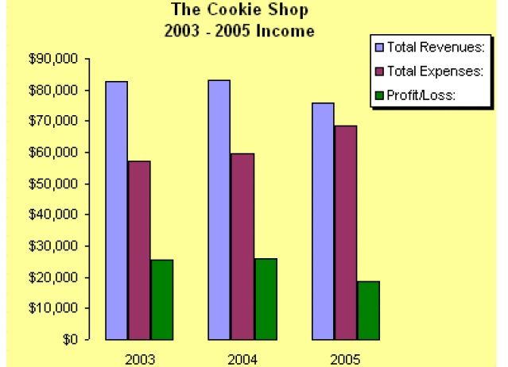
________________________________________
___________________________________________________________________________________
___________________________________________________________________________________
___________________________________________________________________________________
__________________________________________________________________________________
__________________________________________________________________________________
___________________________________________________________________________________
___________________________________________________________________________________
___________________________________________________________________________________
___________________________________________________________________________________
___________________________________________________________________________________
___________________________________________________________________________________
___________________________________________________________________________________
___________________________________________________________________________________
___________________________________________________________________________________
GOOD LUCK

