ENGLISH 002 GRAMMAR WORKSHEET – (3)
Q(1) Describe the pictures using the Present Perfect.

1) Someone has eaten the apple.
2) ______________________________________________________.
3) ______________________________________________________.
4) ______________________________________________________.
5) ______________________________________________________.
Q(2) Describe the pictures using the Present Perfect Progressive.
1) The baby has been crying for five minutes.
2) _____________________________________________________.
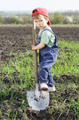 3) _____________________________________________________.
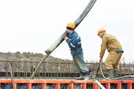 4) _____________________________________________________.
5) _____________________________________________________.

Q (3) Describe the pictures using couldn’t / can.

1) He couldn’t sew when he was young, but now he can sew.
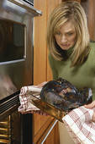 2) ________________________________________________.
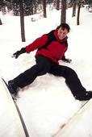 3) ________________________________________________.
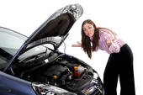 4) ________________________________________________.
5) ________________________________________________.

Q(4) Form correct sentences using ( must / mustn’t / don’t have to ) and the information in the table below.
Aramco has vacant jobs for office managers with the following conditions.
Nationality | All Nationals
Age | Over 25
Gender | Male
Languages | English / French
Experience | Not Necessary
*Note : Smokers can’t apply for this job.
1) You don’t have to be a Saudi to apply for this job.
2) _____________________________________________________________.
3) _____________________________________________________________.
4) _____________________________________________________________.
5) _____________________________________________________________.
6) _____________________________________________________________.
Q(5) Make Wh-questions to the underlined phrases.
Peter is a very famous mechanic in his town. He can fix small and large vehicles. He owns a large garage downtown. He opened his garage in 2005. Since then, he has known most taxi drivers in town. Peter is too busy this week. He is fixing Jason’s truck which has been in the garage for three weeks. Sometimes Peter has to work on weekends to satisfy his customers.
1) __________________________________________? Small and large vehicles
2) __________________________________________? In 2005
3) __________________________________________? Since 2005
4) __________________________________________? For three weeks
5) __________________________________________? To satisfy his customers.

Q(6) Give the best advice using should / shouldn’t.
1) Claudia has a severe toothache.
A) She should see a dentist.
B) She shouldn’t eat sweets.
2) Majid is going to travel to Malaysia next week.
A) ______________________________________________________________.
B) ______________________________________________________________.
3) It’s raining heavily and the roads are slippery.
A) ______________________________________________________________.
B) ______________________________________________________________.

Q(7) Use the information in the table to make sentences using already / yet.
clean the house | Yes
make lunch | No
do my homework | No
check my e-mail | Yes
buy groceries | No

1) I have cleaned the house already.
2)______________________________________________________________.
3)______________________________________________________________.
4)______________________________________________________________.
5)______________________________________________________________.

GOOD LUCK

