ENGLISH 002 GRAMMAR WORKSHEET – (4)
Q (1) Use the PASSIVE VOICE to describe how scrambled eggs are prepared.
1 2 3 4 5
beat add put fry serve
First, the eggs are beaten in a bowl. Next, ______________________________
____________________________________________________________________
____________________________________________________________________
____________________________________________________________________
____________________________________________________________________
Q (2) Make Wh-questions to the underlined phrases.
i-Phones are considered smart devices because they can do many jobs at the same time. They are designed for making communication among people easier and more interesting. In addition, i-Phones are equipped with several software programs that enable people to do without computers. Nowadays, most young people are amazed by their hi-tech features and accessories.
1)_________________________________________________________________?
2)_________________________________________________________________?
3)_________________________________________________________________?
4)_________________________________________________________________?

Q (3) Describe the process of making furniture using the PASSIVE VOICE.
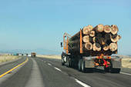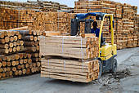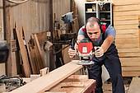
cut transport store shape sell
These pictures describe the process of making wood furniture. First, trees are cut down. Next,__________________________________________________________
____________________________________________________________________
____________________________________________________________________
____________________________________________________________________
____________________________________________________________________
Q (4) Describe what happened to Peter last week using the PASSIVE VOICE.
attack take examine give question visit

Last week, Peter was attacked in his shop by some burglars.__________________
____________________________________________________________________
____________________________________________________________________
____________________________________________________________________
____________________________________________________________________
Q(5) Change the sentences below into Passive voice.
1) Samsung makes smartphones and digital cameras.
______________________________________________________________________.
2) India has launched a satellite into space.
______________________________________________________________________.
3) Housewives will use robots to do household chores in the future.
______________________________________________________________________.
4) The manager canceled yesterday’s meeting.
______________________________________________________________________.
5) Did the police catch the thief last week?
______________________________________________________________________?
6) Most people in this town know me very well.
______________________________________________________________________.
7) Mr. Brown is teaching the French course.
______________________________________________________________________.
8) Illegal hunters kill the elephants in Africa.
______________________________________________________________________.
9) Farmers grow vegetables and wheat in Qassim.
______________________________________________________________________.
10) The manager will contact the successful candidates.
______________________________________________________________________.

GOOD LUCK

