English 002 Practice Quiz - 4
Q (1) Use the PASSIVE VOICE to describe how scrambled eggs are prepared.
1 2 3 4 5
beat add put fry serve
First, the eggs are beaten in a bowl. Next, ____________________________
____________________________________________________________________
____________________________________________________________________
____________________________________________________________________
____________________________________________________________________
Q (2) Make Wh-questions to the underlined phrases.
iPhones are considered smart devices because they can do many jobs at the same time. They are designed for making communication among people easier and more interesting. In addition, iPhones are equipped with several software programs that enable people to do without computers. Nowadays, most young people are amazed by their hi-tech features and accessories.
1)_________________________________________________________________?
2)_________________________________________________________________?
3)_________________________________________________________________?
4)_________________________________________________________________?

Q (3) Describe the process of making furniture using the PASSIVE VOICE.
1 2 3 4 5
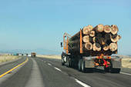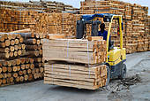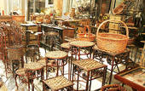
cut transport store shape sell
These pictures describe the process of making wood furniture. First, trees are cut down. Next,__________________________________________________________
____________________________________________________________________
____________________________________________________________________
____________________________________________________________________
____________________________________________________________________
____________________________________________________________________

Q(4) Define each person’s job using “who”.
1) A pilot is someone who flies planes.
2) A mechanic__________________________________________________.
3) A teacher___________________________________________________.
4) A florist_____________________________________________________.
5) A barber____________________________________________________.
6) A waiter____________________________________________________.
7) A farmer____________________________________________________.
8) A photographer______________________________________________.
Q (5) Define the places in the pictures using “where”.
1) A pharmacy is a place where people buy medicines.
2) A stadium__________________________________________________.
3) A grocery store_____________________________________________.
4) A café____________________________________________________.
5) A gym____________________________________________________.
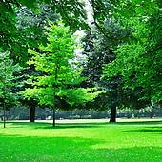 6) A park____________________________________________________.

Q (6) Describe what happened to Peter last week using the PASSIVE VOICE.

attack take examine give question visit

Last week, Peter was attacked in his shop by some burglars.__________________
____________________________________________________________________
____________________________________________________________________
____________________________________________________________________
____________________________________________________________________
____________________________________________________________________
____________________________________________________________________.

GOOD LUCK

