ENGLISH 002 GRAMMAR WORKSHEET – (2)
Q(1) Use the IMPERATIVE to describe how you make a fruit salad.
1) Bring a banana , an apple , an orange and a kiwi.
2) __________________________________________________________________.
3) __________________________________________________________________.
4) __________________________________________________________________.
5) __________________________________________________________________.

Q(2) Use the verbs given to form sentences with Future Time Clauses.
1) save / buy
- When I save enough money, I will buy a digital camera.
2) finish / surf
____________________________________________________________________.
3) travel / visit
____________________________________________________________________.
4) graduate / start
____________________________________________________________________.
5) have / check
____________________________________________________________________.
6) pass / take
____________________________________________________________________.

Q(3) Make Wh-Questions to the underlined phrases.
1) Peter wrote a nice story last week.
- What did Peter write last week?
2) Three burglars broke into Jack’s house last night.
_____________________________________________________________________.
3) Faisal owns a famous restaurant downtown.
_____________________________________________________________________.
4) Peter and Henry have a business meeting tomorrow morning.
_____________________________________________________________________.
_____________________________________________________________________.
5) My cousin was listening to the radio when the accident took place.
_____________________________________________________________________.
6) I didn’t catch the train because I overslept.
_____________________________________________________________________.
7) Our trip to Riyadh will take five hours.
_____________________________________________________________________.
8) Martin visits the museum once a month.
_____________________________________________________________________.
9) Rania’s daughter won the prize last week.
_____________________________________________________________________.
10) Tom is doing some stretching exercises at the gym.
_____________________________________________________________________.

Q(4) Use the IMPERATIVE to describe the steps of withdrawing money from an ATM.
1) Insert the card in the slot.
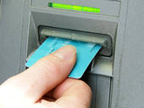
2) ____________________________________________________________________.
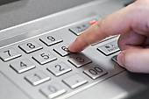
3) ____________________________________________________________________.
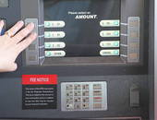
4) ____________________________________________________________________.
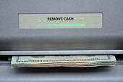
5) ____________________________________________________________________.
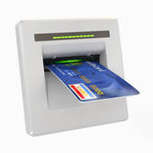

Q(5) Write four sentences about your future plans on your trip to Dubai next month.

1) I am going to stay in a five-star hotel.
2) ___________________________________________________________________.
3) ___________________________________________________________________.
4) ___________________________________________________________________.
5) ___________________________________________________________________.

Q(6) Write four sentences about your predictions for the future.

1) People will use electric cars all over the world.
2) ___________________________________________________________________.
3) ___________________________________________________________________.
4) ___________________________________________________________________.
5) ___________________________________________________________________.

GOOD LUCK

