**English 002 Grammar Practice Quiz – (1)**

**Q(1) Describe how Jack’s habitual activities have changed using the Simple Present and the Present Progressive.**

1)

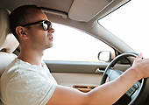 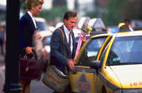 Jack usually **drives** to work, but today he **is taking** a taxi.

2)

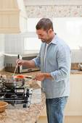 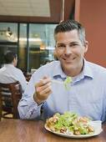 ______________________________________________.

3)

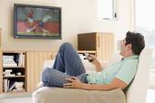 _______________________________________________.

4)

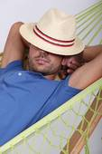 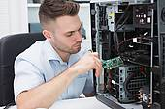 ________________________________________________.

5)

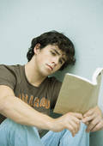  ________________________________________________.

**Question (2) Use the Simple Present and Future forms to describe the pictures.**

 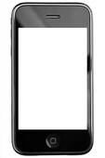1) When he **saves** some money, he **will buy** an I-phone.

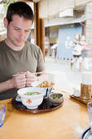  2) ____________________________________________.

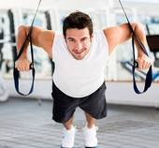 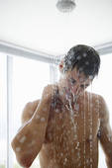 3) ____________________________________________.

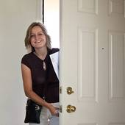 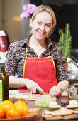 4) ____________________________________________.

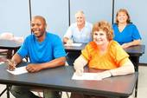 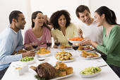 5) ____________________________________________.

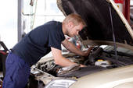 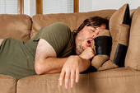 6) ____________________________________________.

**Q(3) Use the IMPERATIVE to describe the steps of withdrawing money from an ATM.**

1) **Insert** the card in the slot.

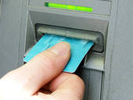

2) ____________________________________________________________________.

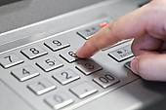

3) ____________________________________________________________________.

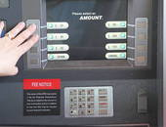

4) ____________________________________________________________________.

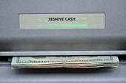

5) ____________________________________________________________________.

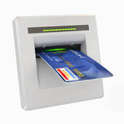

**Q(3) Describe the pictures using the Simple Past & the Past Progressive.**

1) The man **fell down** while he **was painting** the house.

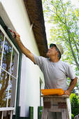 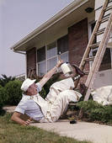

2) ____________________________________________________________________.

 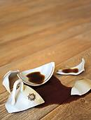

3) ____________________________________________________________________.

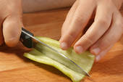 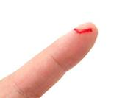

4) ____________________________________________________________________.

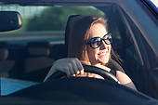 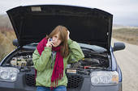

5) ____________________________________________________________________.

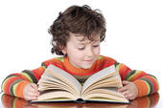 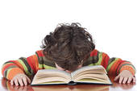

**Q(4) Describe the pictures using the Simple Past.**

1) Peter **ate** an apple this morning.

http://d.adroll.com/cm/f/outhttp://www.googleadservices.com/pagead/conversion/1032613984/?label=kwpJCOLa_gIQ4OCx7AM&guid=ON&script=0&ord=5433424182954087http://d.adroll.com/cm/g/out?google_nid=adroll

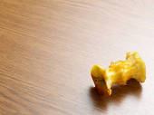

2) ____________________________________________________________________.

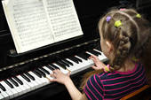

3) ____________________________________________________________________.

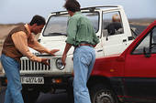

4) ____________________________________________________________________.

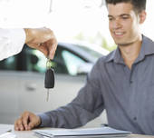

5) ____________________________________________________________________.

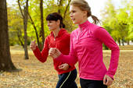 **GOOD LUCK**