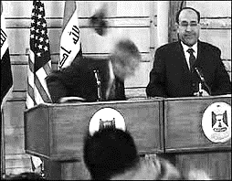
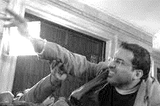
George Bush , feel,
Muntadar, throw

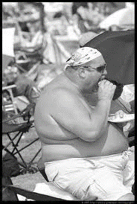
- ______________________________________________________________________________
Big Mike, have lunch,
Big Mike, sunbathe
- _______________________________________________________
______________________________________________________________
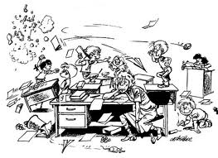
Teacher, sleep
Class, study (no)
- ______________________________________
_________________________________________
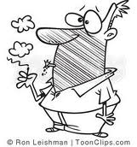

Mark, smoke
Cigarette, explode
4. __________________________________________________
____________________________________________________

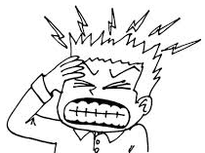
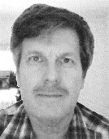
Grammar, grammar, blah, blah, blah

Michael, explain, past progressive
I, get/had, headache
- _____________________________________________________________________
______________________________________________________________________

