JIC ELC
ENGLISH 001 WRITINGPRACTICE
Study the information about Hollywood celebrity Arnold Schwarzenegger and write a short biography.

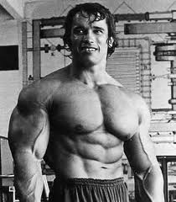
professional body builder- actor- ex-governor of California
July 30, 1947 - Austria
Body building years : Fitness champion – 11 times
1968 - the USA
1975 - first film : “Pumping Iron”
1976 - Golden Globe Award - the best new actor
2003- Governor of California
Today : single
married with Maria Shriver (10 years)
four children
Future : a book about his life
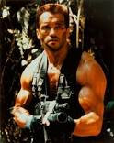
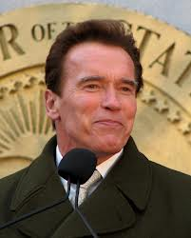
ARNOLD SCHWARZENEGGER
_____________________________________________
_____________________________________________
_____________________________________________
_____________________________________________
_____________________________________________
_____________________________________________
_____________________________________________
_____________________________________________
_____________________________________________
_____________________________________________
_____________________________________________
_____________________________________________
_____________________________________________
_____________________________________________
_____________________________________________

