Question (1) Use the information in the table and the box below to write correct sentences about the four drivers.
Driver | Car Model | Car Price | No. of Accidents | Monthly visits to London
Alex | 2005 | $25,000 | None (0) | Twice
John | 2008 | $28,000 | (2) | Three times
Peter | 2002 | $17,000 | (5) | Five times
Carlos | 2011 | $42,000 | (3) | Once

careful - new - few - careless - expensive
cheap - many - old - frequent - good
- Comparative Adjectives:
A) John’s car is newer than Peter’s.
B)________________________________________________________________.
C)________________________________________________________________.
D)________________________________________________________________.
- Superlative Adjectives:
A) Carlos has the newest car of all.
B)________________________________________________________________.
C)________________________________________________________________.
D)________________________________________________________________.
- Comparative Adverbs:
A) John drives more carefully than Carlos. B)________________________________________________________________.
C)________________________________________________________________.
D)________________________________________________________________.

- Superlative Adverbs:
A) Alex drives the most carefully of all.
B)_______________________________________________________________.
C)_______________________________________________________________.
D)_______________________________________________________________.
Question(2) Use the adjectives to write double-comparative sentences.

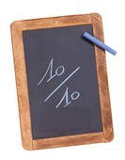
hard high A) The harder you study, the higher scores you get.
healthy strong B)_________________________________________.
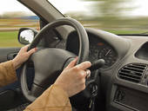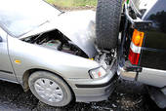
slow few C)__________________________________________.

Question (3) Use the pictures to write repetitive comparatives.

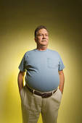 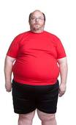A) He’s getting fatter and fatter.
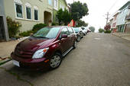 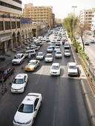 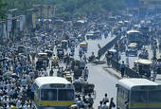 B) _________________________________________.
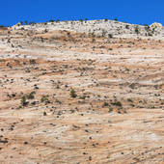 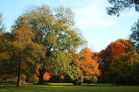 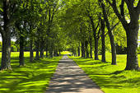 C) __________________________________________.

Question (4) Write four sentences about your future plans on your trip to Dubai next month.
1) I am going to visit Khalifa Tower.
2)________________________________________________________________.
3)________________________________________________________________.
4)________________________________________________________________.
5)________________________________________________________________.

GOOD LUCK

