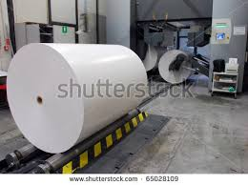
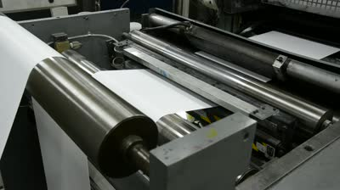
Describing a Process

Making Newspapers

Write an article on the stages of production of newspapers. Include guide words firstly, secondly, then, after that, later, finally etc. (10 marks) Use your own words.

Steps | Action | Parts | How/Where | Result
1 | deliver | large rolls of paper and ink | trucks to print factory | rolls ready for printing
2 | press | paper rolls/ ink plates | print press | news printed
3 | cut | printed news / sheets | cutting machine | news sheets ready
4 | assemble | news sheets/newspapers | forming machine | newspapers ready
5 | pack | newspapers tied up | packing room | packed newspapers ready
6 | send | newspaper packages | trucks and vans | supermarkets and shops

Production of Newspapers
The stages of making newspapers are very easy. Firstly, large rolls of paper and ink are delivered in trucks to the print factory. Then, the rolls are ready for printing. Secondly,_____________
_____________________________________________________________________________________________________________________________________________________________________________________________________________________________________________________________________________________________________________________________________________________________________________________________________________________________________________________________________________________________________________________________________________________________________________________________________________________________________________________________________________________________________________________________________________________________________________________________________________________________________________________________________________

